Workshop on
The Third Grand Challenges India Grant Opportunity ‘All Children Thriving’ 13th – 20th November 2014

PMU – BIRAC, 26th November 2014

Multi sectorial interventions in the context of maternal and child health, with reference to the identified priorities of RFA - All Children Thriving

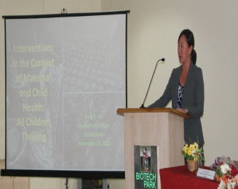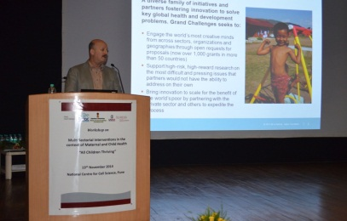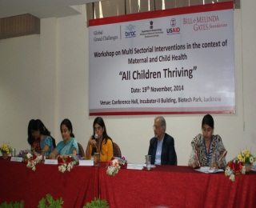
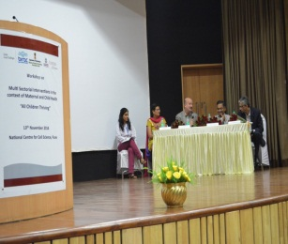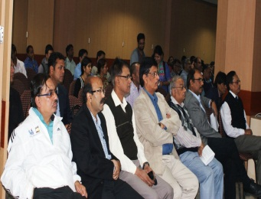

‘All Children Thriving’, a third Grand Challenge India grant opportunity was launched in October 2014, under the partnership of DBT-BMGF-BIRAC along with USAID. Being able to effectively disseminate & to empower potential applicants with necessary tools for the Grant opportunity, a one day workshop was conducted in five cities from 13th Nov. to 20th Nov. 2014, so as to enable them to articulate and submit Letter of Intent(s) LOI(s).

The purpose of this workshop was to bring together the key stakeholders to discuss the key issues related to mother and child and also, to share information and raise awareness about the call – ‘All Children Thriving’. A detailed overview of the ‘Request For Application’ (RFA), was provided, which highlighted the eligibility criteria, evaluation process and other relevant details for prospective applicants. Panel discussions were held on multi-sectorial interventions in the context of Maternal & Child Health, with reference to the identified priorities of the RFA in India and other developing countries that focussed on multidisciplinary approach to develop package of interventions in tackling this challenge. In addition, workshop included past successful grantees of Bill Melinda Gates Foundation who shared their experiences with Grand Challenges.

The first workshop was conducted in NCCS, Pune which brought together 100 participants. The panel discussion highlighted the insights of Maharashtra Nutrition Mission and the interventions around it. The second workshop at ICT Mumbai, with a footfall of more than 65, showcased the clinical interventions on maternal and child health. The third in the series was at KIIT, Bhubaneswar where 85 attendees gained knowledge on interventions in agriculture, food security, fortified foods and nutrition. At Biotech Park, Lucknow, the workshop brought together 70 participants, where the discussion focussed on maternal and child health with integrated agriculture & nutrition practices, clinical interventions and surveys. NIN Hyderabad, hosted the last workshop with an overwhelming participation from 115 prospective applicants and the discussion was centred on nutrition intervention.

The workshops concluded with interactive session with the participants.

The specific learnings for the participants after workshop are detailed below:
- Current status and nature of multisectoral strategies and goals for maternal and child health in the India and other Low Income Countries;
- Promising good practices implemented by the any sector to promote maternal and child health in the India and other Low Income Countries;
- Strategies that can be used to engage the private sector, government and civil society in collaborative efforts to combat the burden of foetal growth impairment and preterm birth, stunted postnatal growth, and impaired cognitive development in the India and other Low Income Countries;
- Key players within any sector in India that can intervene to make a greater impact to existing or new bio repositories;
- Signs of progress that would indicate the growth of social responsibility.

These kind of the workshop helps us to refine our processes in order to receive relevant proposals in context of the announced calls.

